If we want to do analysis on multiple variable, then this analysis is known as Multivariate analysis, for ploting the PDF for two feature PW, PL countour will be plotted.

Consider an example given in below figures,

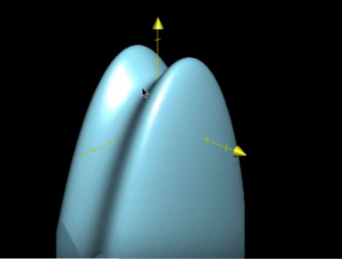

So for this we get a mountain shape structure, now we make slices on z-axis.

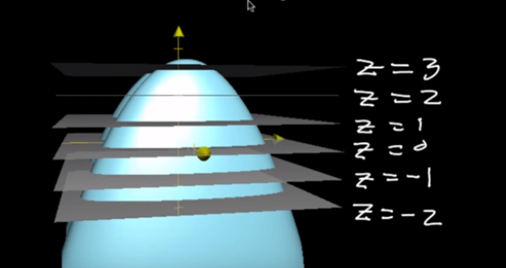

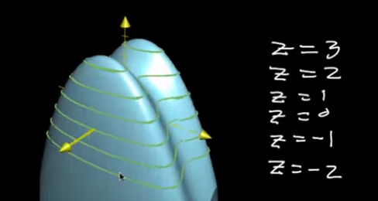

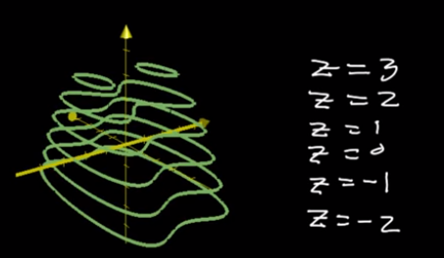

Now we just put them in 2-D xy plane as which give us Contour.

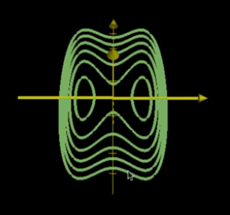

Consider an example where PL is on x-axis, PW is on y-axis and PDF prob is on z-axis, so we get it’s contour as given below for setosa iris.

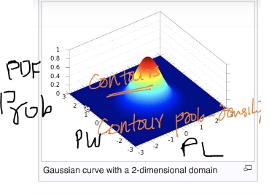

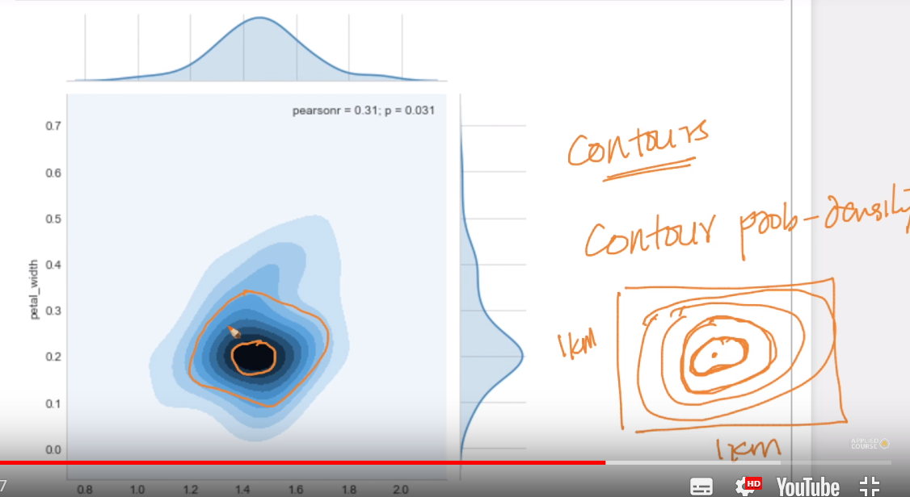

The density we got here is known as **Contour probability density,** and this prob density is very useful in determining the highest density are for two variables and in our case for the highest density or large no. of setossa are there within which PL and PW

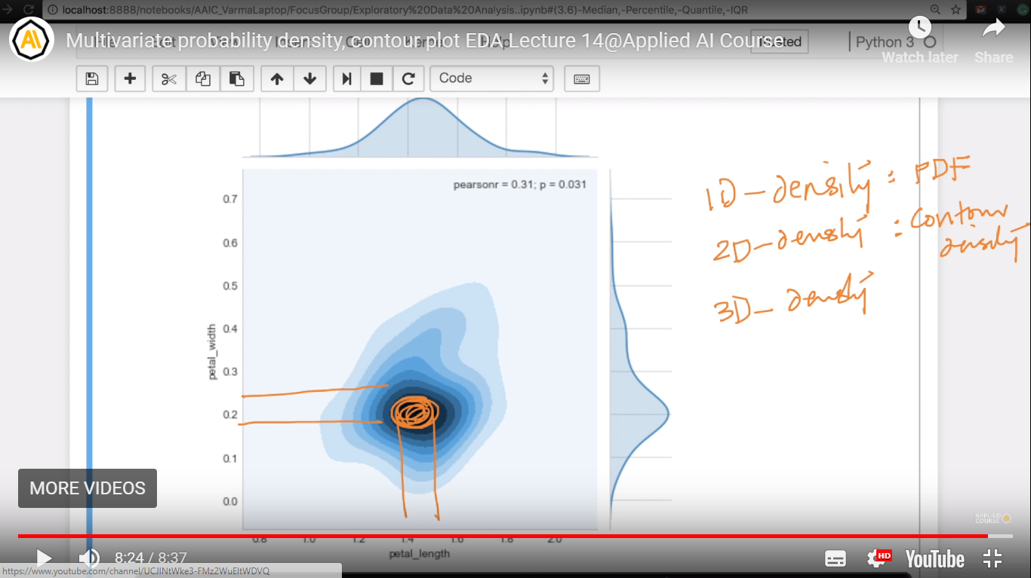

**How to plot contour plot**

